--> A table named olympic has been created with the following details in hive i have used acadgild_db for my program execution.

The data set consists of the following fields.
===================================
Athlete: This field consists of the athlete name
Age: This field consists of athlete ages
Country: This fields consists of the country names which participated in Olympics
Year: This field consists of the year
Closing Date: This field consists of the closing date of ceremony
Sport: Consists of the sports name
Gold Medals: No. of Gold medals
Silver Medals: No. of Silver medals
Bronze Medals: No. of Bronze medals
Total Medals: Consists of total no. of medals

TABLE CREATION:

create table olympic
(athlete string,age int,country string,year string,c_date string,sports string,gold_medal int,silver_medal int,bronze_medal int,total_medal int)
row format delimited fields terminated by '\t';

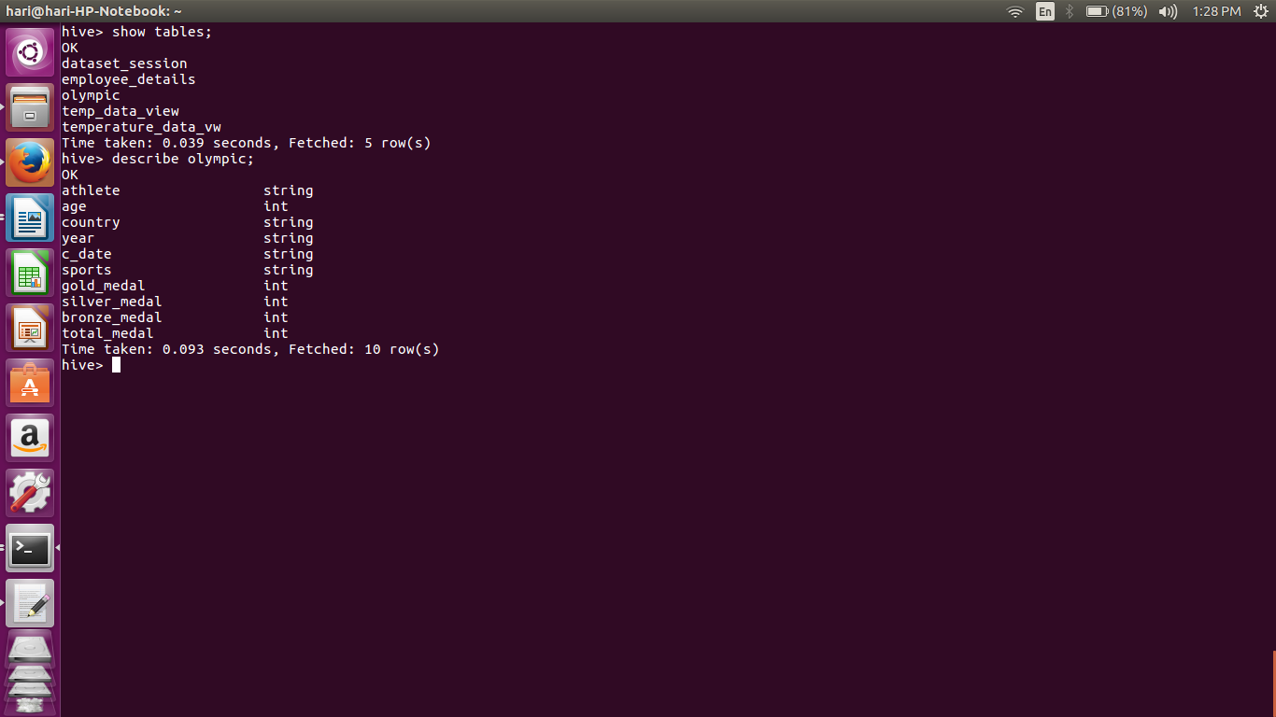

LOADING DATA:
--> I have my data in Downloads so im loading it now

hive> LOAD DATA LOCAL INPATH '/home/hari/Downloads/olympix_data.csv' OVERWRITE INTO TABLE olympic;

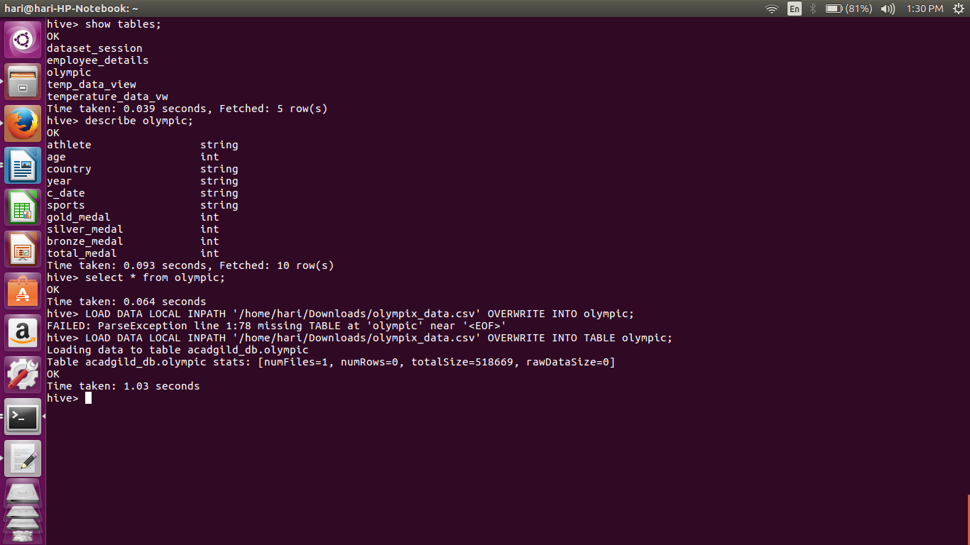
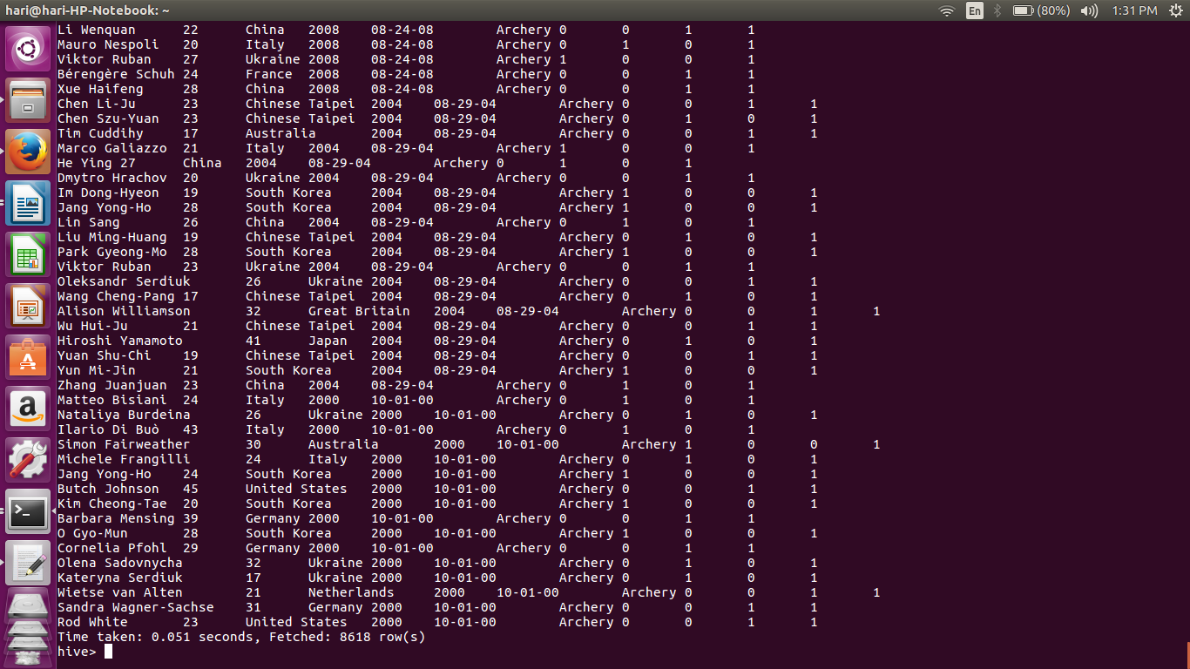

1. Write a Hive program to find the number of medals won by each country in swimming.

hive> SELECT country,SUM(total_medal) from olympic WHERE sport ='Swimming' GROUP BY country;

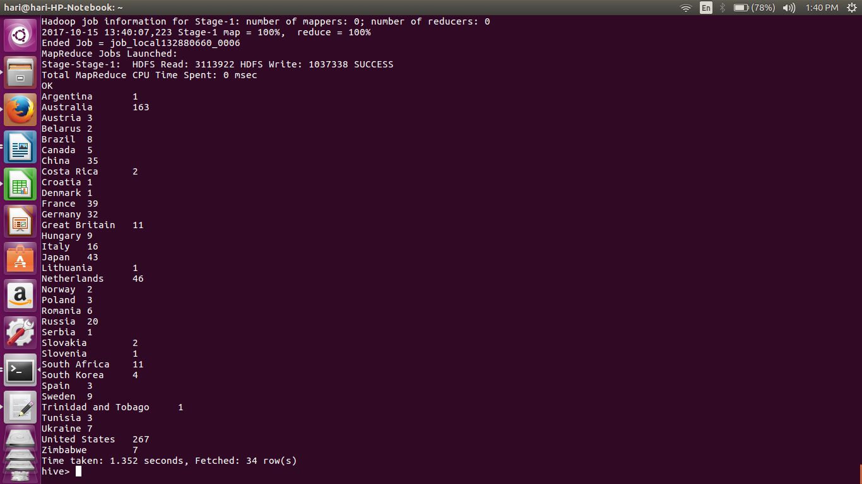

2. Write a Hive program to find the number of medals that India won year wise.

Hive > SELECT year,SUM(total_medal) from olympic WHERE country =’India' GROUP BY year;

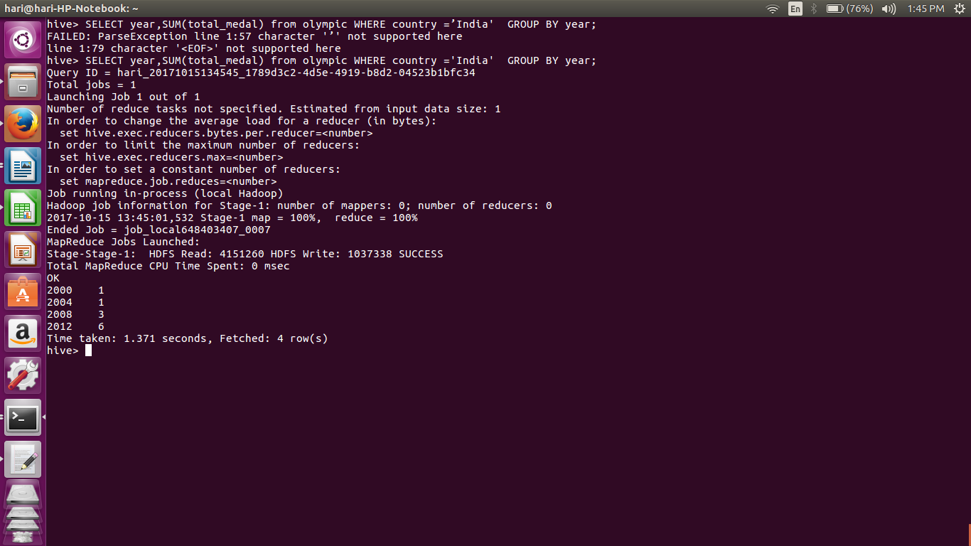
3. Write a Hive Program to find the total number of medals each country won.

hive>SELECT country,SUM(total_medal) from olympic GROUP BY country;

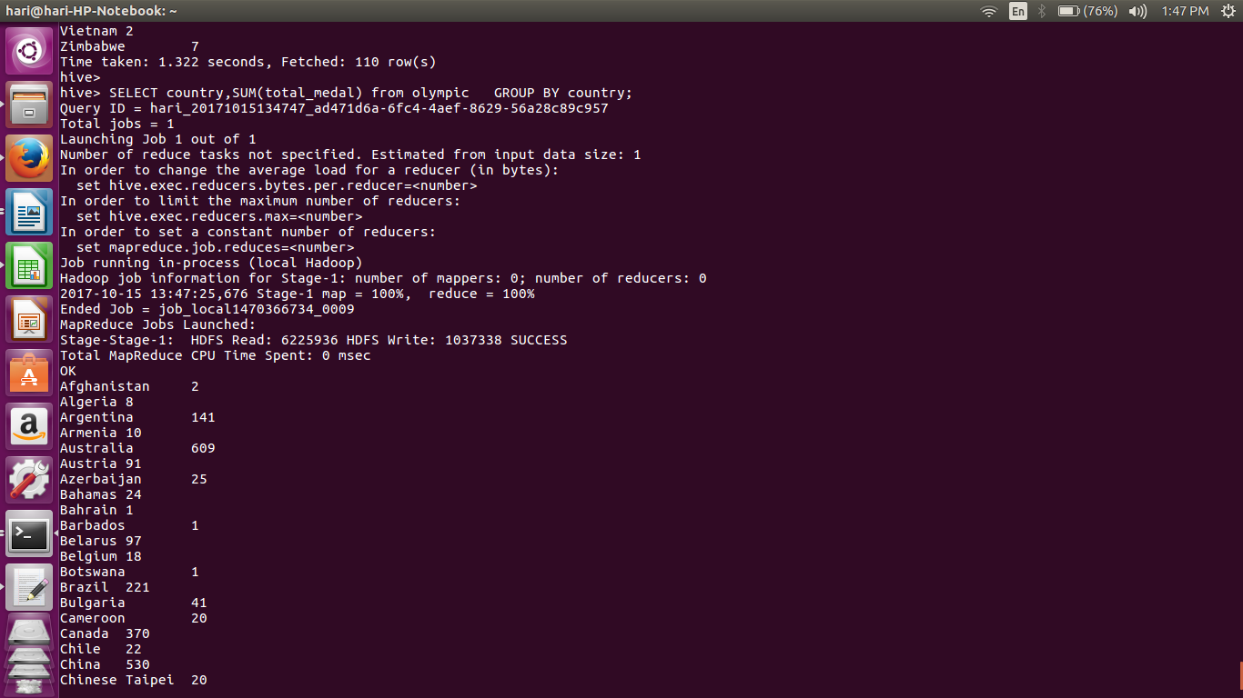
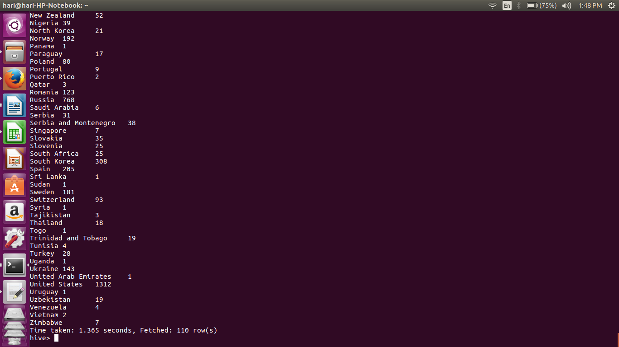

4. Write a Hive program to find the number of gold medals each country won.

hive>SELECT country,COUNT(gold_medal) FROM olympic GROUP BY country;

